Lab# 03: Boosting OOP Proficiency: Exploring Static Components & Object Relationships



Fall 2025

Submitted by

M Mohsin Khan (24pwcse2382)

Class Section: C

“On my honor, as student of University of Engineering and Technology, I have neither given nor received unauthorized assistance on this academic work.”

Submitted to: Engr. Sumayyah Salahuddin

Oct 24th, 2025

Department of Computer Systems Engineering

University of Engineering and Technology, Peshawar

Objectives of the Lab
- Understand how static class components differ from non-static ones in terms of memory allocation and scope of functionality.
- Examine how C++ const members and objects maintain data integrity, enforce immutability, and influence program behaviour.
- Compare objects and pointers in C++, focusing on their roles in function execution, memory management, and the complexity of embedded objects.
- Design and execute test cases to demonstrate a clear understanding of static components, const members, objects, and pointers in C++.

Activity # 3.4.1: Employee Database Management System
Problem Analysis:
Design a class named Employee to represent an employee in a company. The class should include the following features:
A static integer variable totalEmployees to keep track of the total number of employee objects created.
Non-static data members:
a. employeeId (int) to store the employee’s unique identification number.
b. name (character array of size 50) to store the employee’s name.
c. designation (character array of size 50) to store the employee’s job title or position.
A constructor that initializes the employee’s ID, name, and designation, while incrementing totalEmployees each time a new object is created.
Member functions to:
a. Add new employee details.
b. Display employee information.
c. Update existing employee data such as name or designation.
A static member function to display the total number of employees currently in the system.
Demonstrate both static and non-static features by creating and modifying multiple employee objects within the main() function.

Algorithm
• Create a class named Employee.
• Declare a static integer variable totalEmployees to maintain the count of employees.
• Declare non-static members: employeeId, name[50], and designation[50].
• Define a constructor to initialize employee details and increment the totalEmployees variable.
• Define addEmployee() to input employee data.
• Define showEmployeeRecord() to show employee information.
• Define updateEmployeeRecord() to edit existing employee details.
• Define a static showRTotalEmployees() function to show the total number of employees created.
• In the main() function, create multiple Employee objects, use the defined functions to add, display, and update records, and show the total number of employees to demonstrate the distinction between static and non-static behaviour.

Hand written Code:
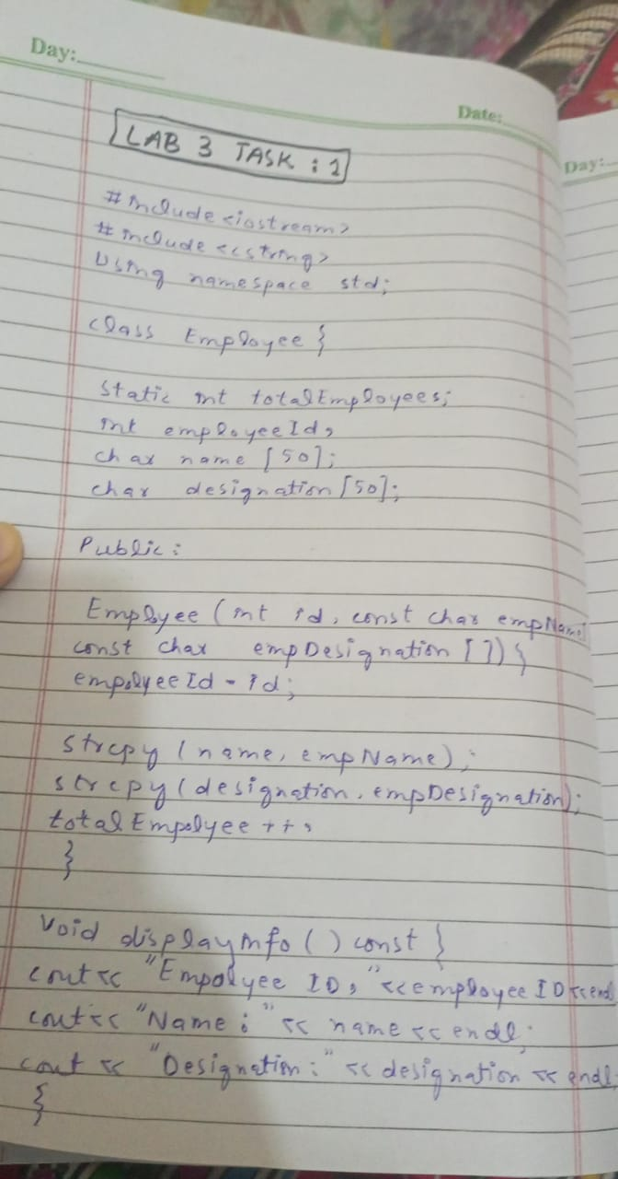

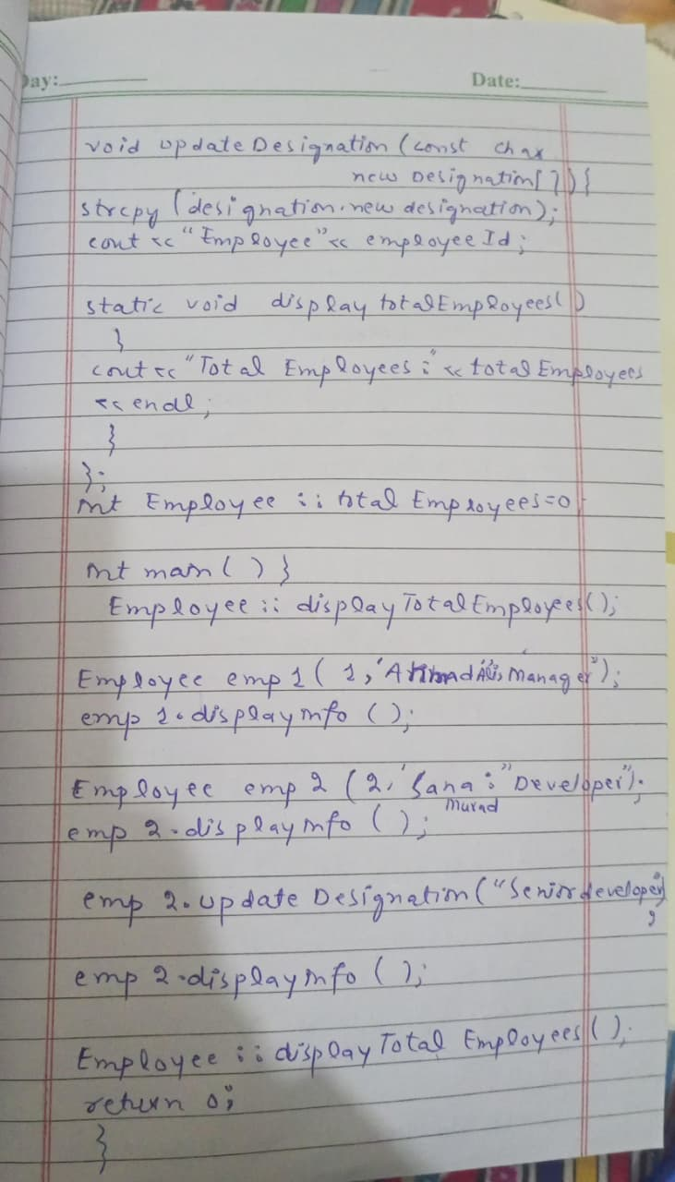

2.5.1 ML Diagram:
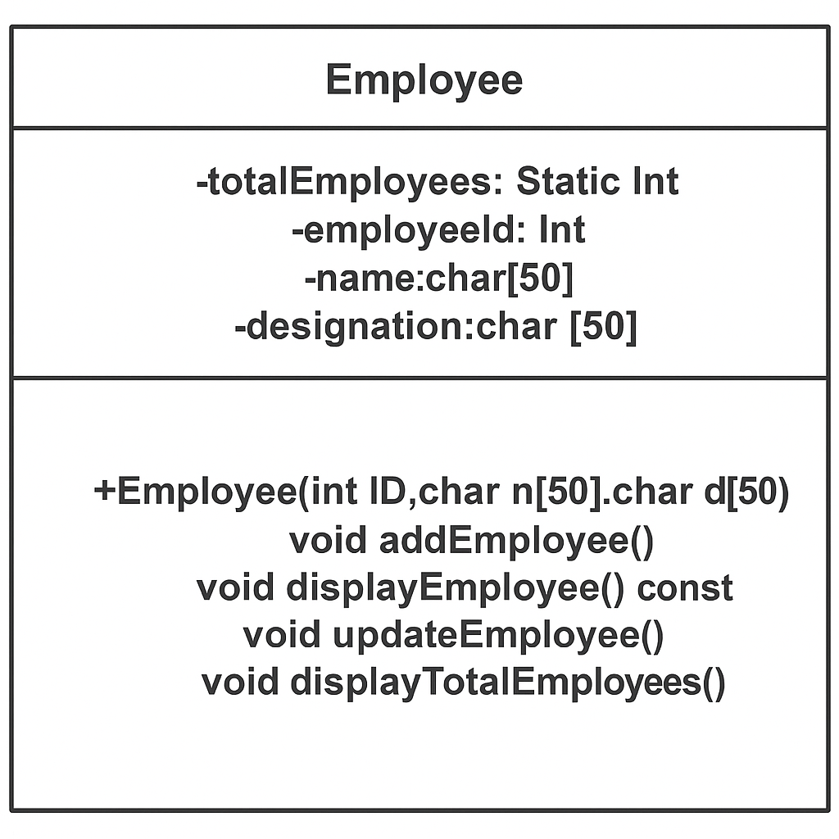

2.5.2 Flow Chart
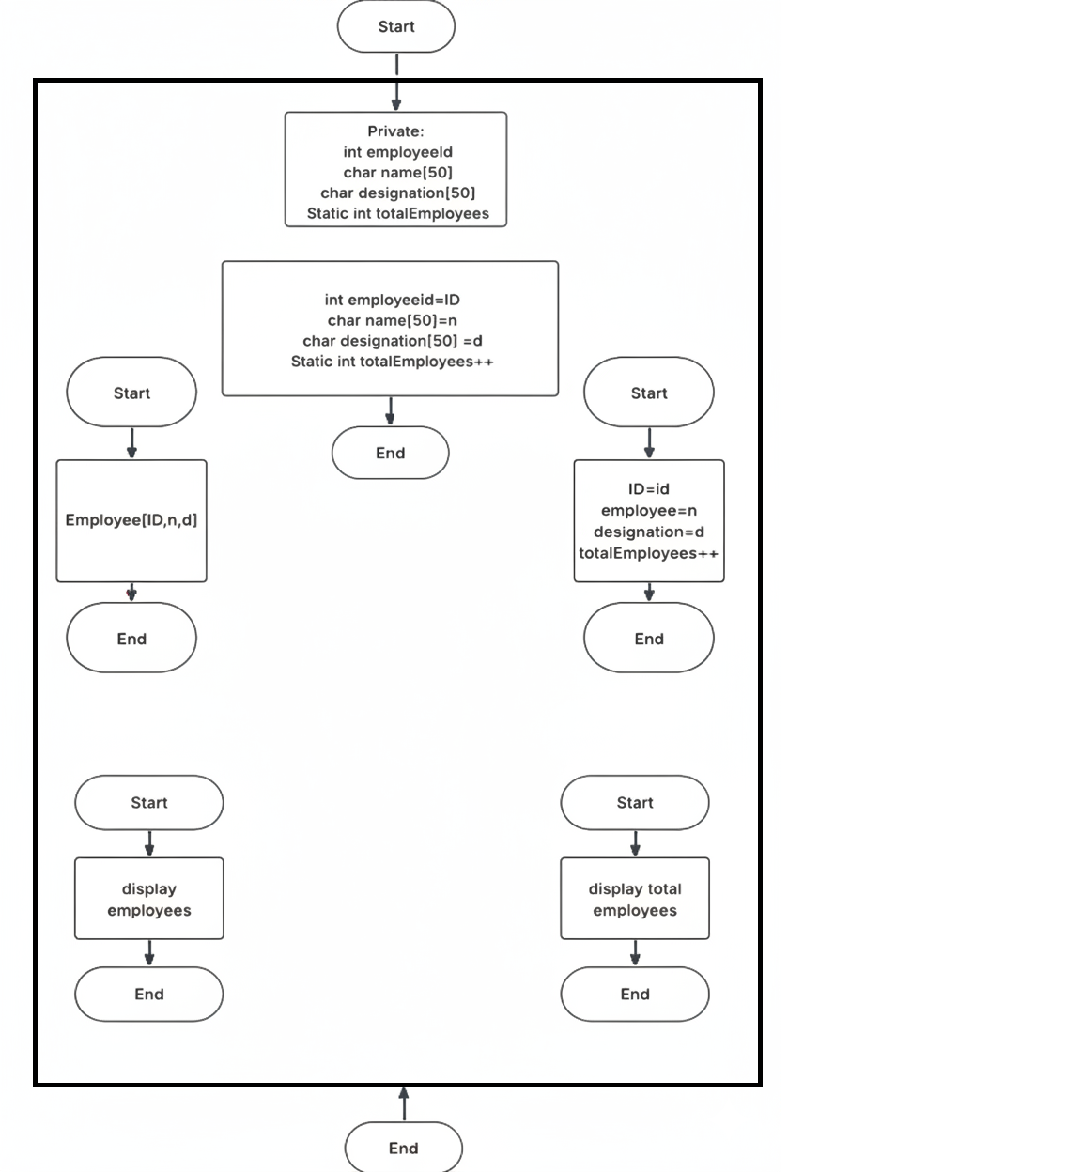
Start
End
Employee::showTotalEployees()

e2.showEmployeeRecord()
e3.showEmployeeRecord()

e2.updateEmployee()
e3.updateEmployee()

Employee e4,
e4.addEmployee(),

e1.showEmployee()
e2.showEmployee()
e3.showEmployee()

Employee e1(parameters),
Employee e2(parameters),
Employee e3(parameters)

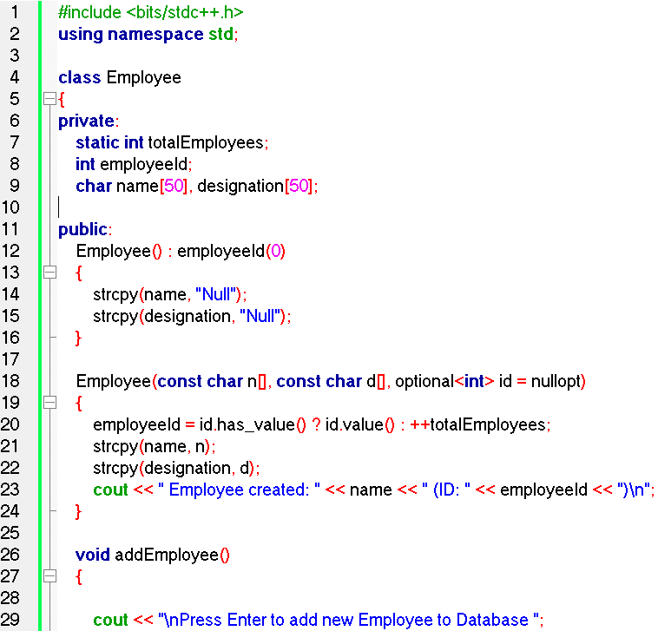
2.5.1 Source Code:
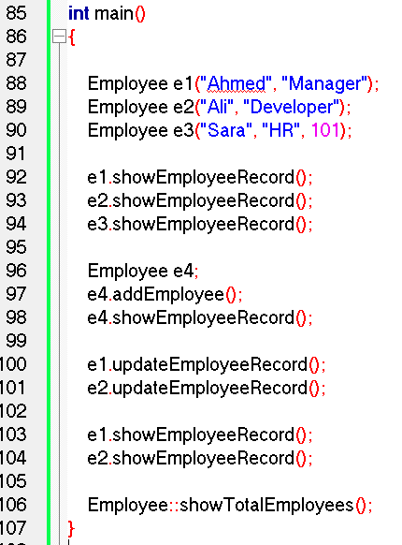
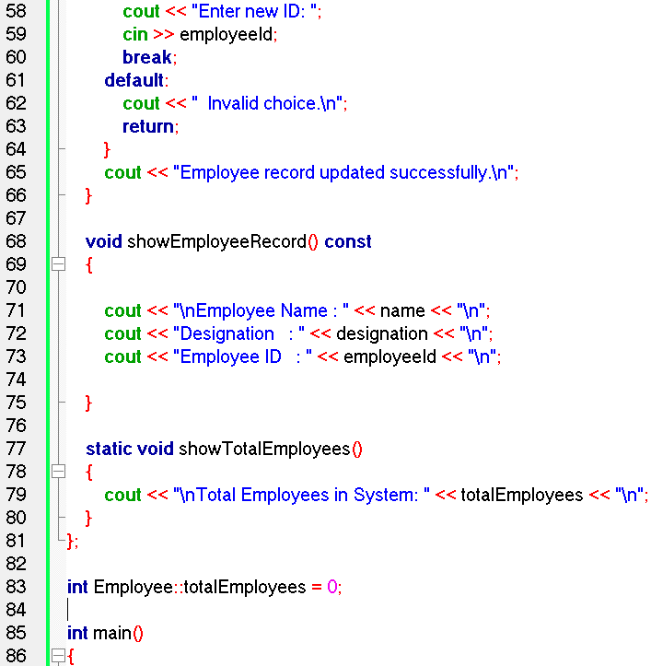
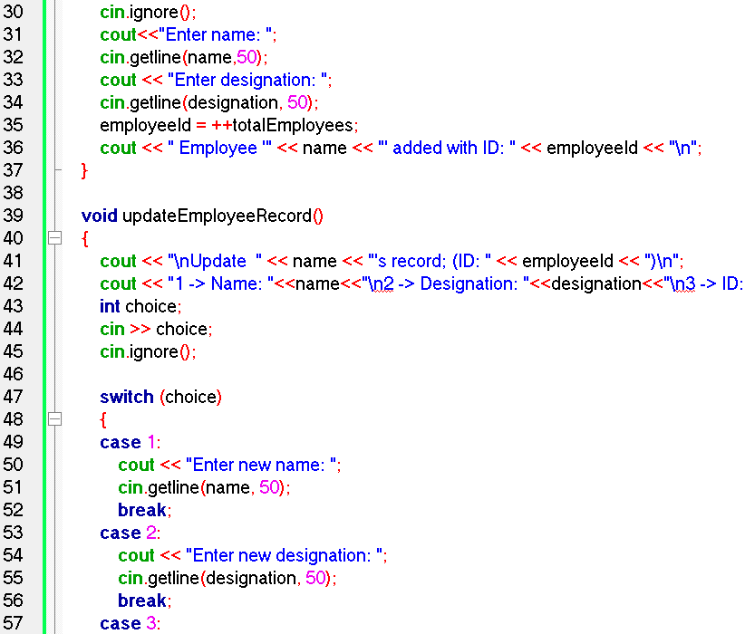

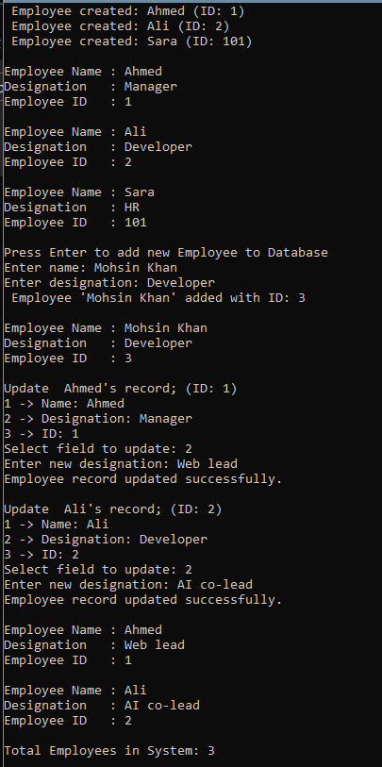
Output:

3.4.2 Activity: Bank Account Management System
1. Design a class BankAccount to represent a bank account, incorporating const members to
store the account holder's personal details. Ensure that these details remain unchanged
throughout the account's lifetime.
2. Write functions to deposit and withdraw funds, along with a method to display the account
holder's information.
3. Illustrate the practical use of const members and objects within the banking context.

Hand Written Source Code:
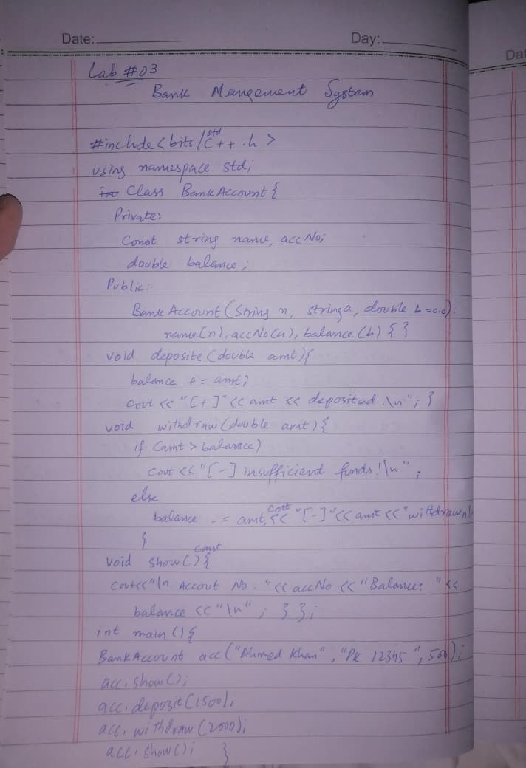

Flow Chart:
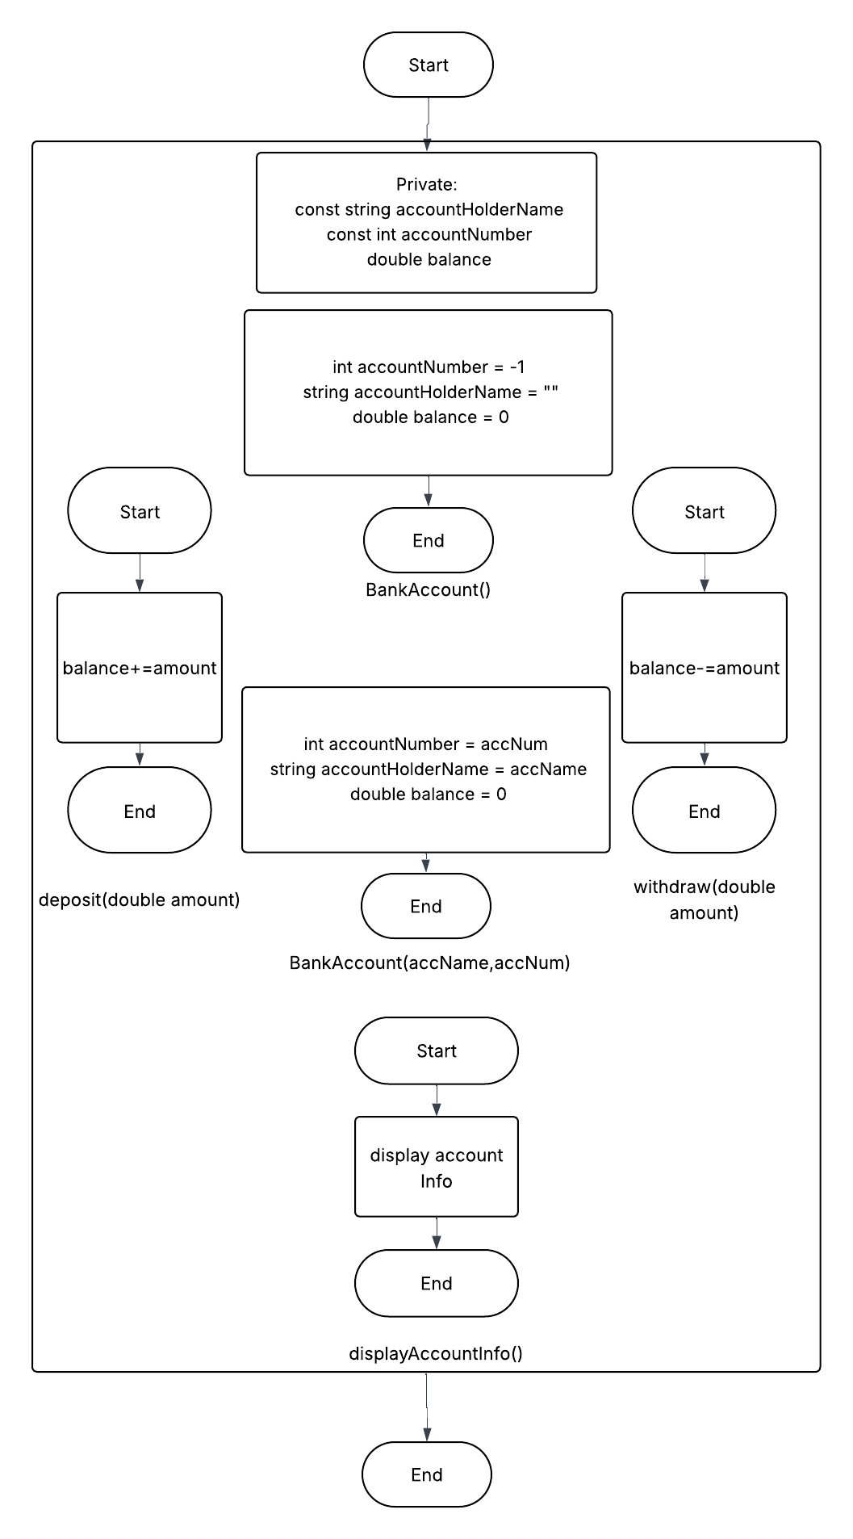

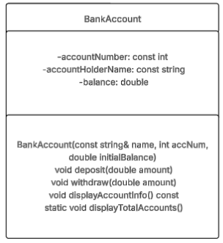
UML Diagram:

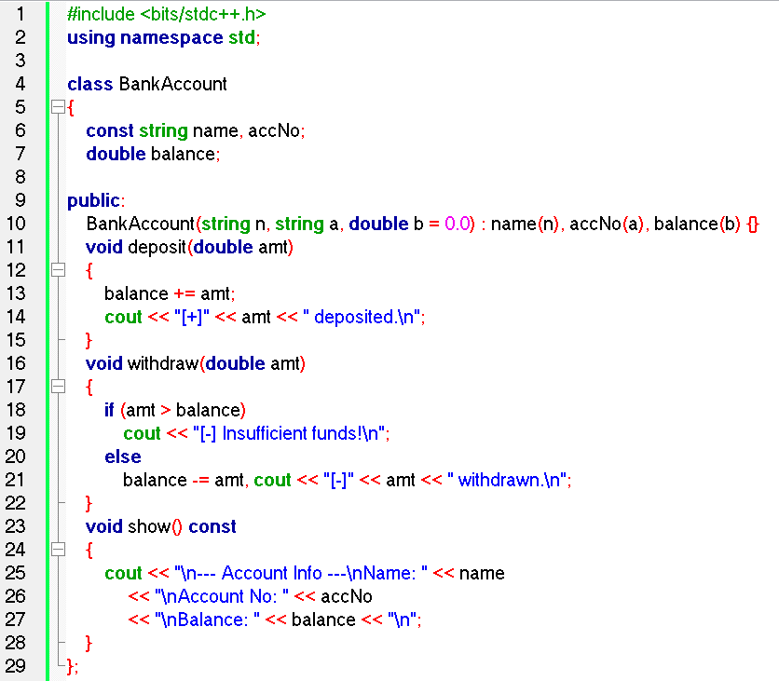
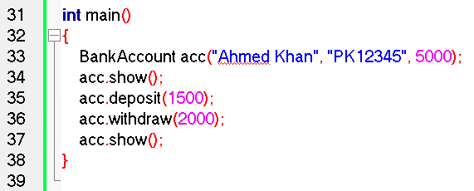
Source Code:

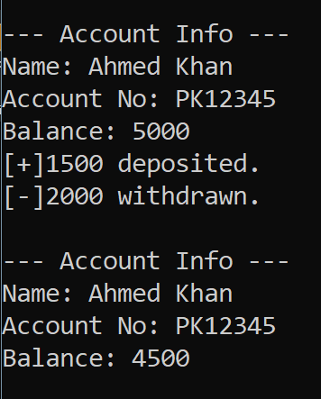
Output:

